
QUALITY ALERT

Customer: Golden Date: November 13, 2023
Die: 15601 Colour: ALL
Type of Complaint: Vision Coating Complaint

Q.A # Q.I.R # CUSTOMER NCR #

Description: Customer Complainted due to material have extra vinyl thread that affects the painting process
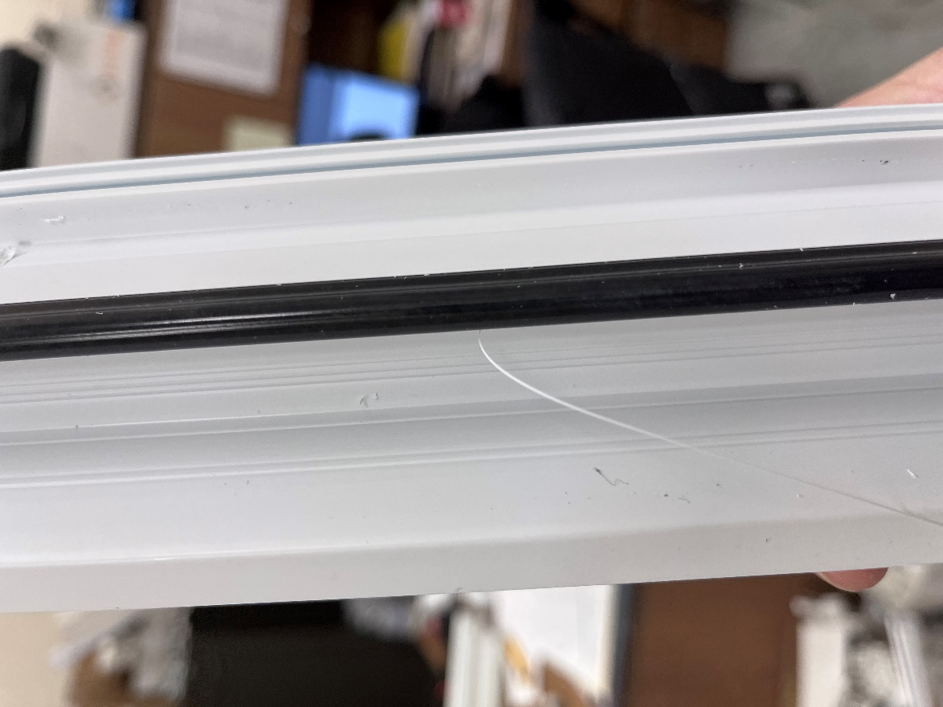

PLEASE MAKE SURE DO NOT HAVE ANY EXTRA VINYL
APPLY ALL GOLDEN MATERIAL

BY SIGNING BELOW, YOU ACKNOWLEDGE THE PROBLEM ABOVE AND AGREE TO MONITOR THIS ISSUE IN FUTURE PRODUCTION RUNS.
DAY SHIFT |  | AFTERNOON SHIFT |  | NIGHT SHIFT
NAME | SIGNATURE | NAME | SIGNATURE | NAME | SIGNATURE

